Puckett Child and Family Therapy
in conjunction with
Shattuck Wellness and Behavioral Health

“LET’S PLAY”

Social Skills Groups
for Children and Teens
with ADHD, Autism &
other developmental disorders.

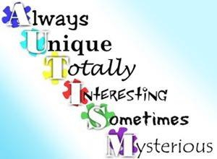

Using AutPlay Therapy, games, role-play, and videos, our groups will:
- Provide structure and predictability
- Break down abstract social concepts into concrete actions
- Simplify language and group children by language level
- Work in pairs or groups with cooperation and partnership encouraged
- Provide multiple and varied learning opportunities
- Foster self-awareness and self-esteem
- Provide opportunities for practice so that skills are used beyond the group in real life settings
*Excerpted from Social Skills Interventions: Getting to the Core of Autism developed for the Interactive Autism Network (IAN) by Teresa j. Fodden and Connie Anderson, Ph.D.

Leader: Suzanne Puckett, M.A.Ed., L.P.C, AutPlay® certified
Dates: TBA
Where: 2501 Atrium Dr #100, Raleigh, NC
Fee: $40 for 30-minute consult (required), $35 per group.
$100 to reserve a spot and $180 due at the first group.
***Most insurance plans will reimburse a percentage of these fees.
***Deposits and advance payments are non-refundable.
To Register: Please complete the online survey http://bit.ly/2OTc6ct or
Email: spuckett@childandfamilytherapy.org

Visit: https://www.puckettchildandfamilytherapy.org/ to learn more about the practice and the group leader.
